**NETWORKING EXERCISE: EMPATHY MAP + AIDA**

1. Choose your target person (e.g., recruiter, HR manager, or IT manager).
2. Fill out the empathy map.
3. Write a concise sequence of messages to create a connection and schedule a meeting with the target person using the AIDA technique.

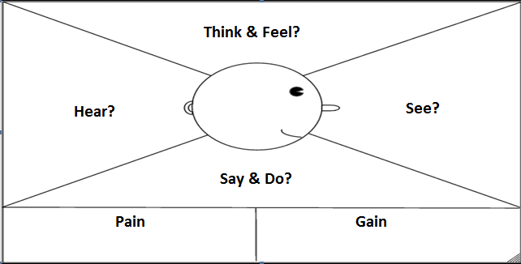

|  |  |
| --- | --- |
| **EMPATHY MAP** | |
| Who are you empathizing with? |  |
| What does he or she need? |  |
| What does he or she feel? |  |
| What does he or she think? |  |
| What does he or she see? |  |
| What does he or she say? |  |
| What does he or she do? |  |
| What does he or she hear? |  |

**Write your sequence of messages using the AIDA technique**

**A**ttention:

**I**nterest:

**D**esire:

**A**ction:

**Example of a message sequence using the AIDA technique**

**Attention:** Hello Mark, I’ve read your article on LinkedIn about the empathy map and UX/UI. It’s very interesting. Thanks for sharing. I hope you will accept my connection invite.

**Interest:** Hi Mark, I’ve developed a check-list for web designers to assure a great user experience. Can I share it with you? Your observations and comments can be very helpful.

**Desire:** Hi Mark, I’ve developed a new app for web designers. It automatically suggests what can be improved in terms of user experience when you design a new interface. It saves time. Would you like to see it? You know that I appreciate your feedback.

**Action:** Good morning Mark, thanks for your feedback. You are very helpful and kind. I’ve just seen that your company is looking for a new web designer. If you think that I could be suitable for the role, would you recommend a specific person inside the company to talk with? Thanks.